#!/bin/bash

add() {

echo "$1 + $2" | bc

}

subtract() {

echo "$1 - $2" | bc

}

multipliy() {

echo "$1 * $2" | bc

}

division() {

if [ "$2" -eq 0 ]; then

echo "Division by 0 is uncomputable."

else

echo "scale=4; $1 / $2" | bc

fi

}

cal() {

case $2 in

"+")

result=$(add "$1" "$3")

;;

"-")

result=$(subtract "$1" "$3")

;;

"*")

result=$(multipliy "$1" "$3")

;;

"/")

result=$(division "$1" "$3")

;;

*)

echo "Your operator is not supported. Supported operators are +, -, *, /"

exit 1

;;

esac

echo "Output = $result"

}

if [ "$#" -ne 3 ]; then

echo "This is the right format $0 <operand1> <operator> <operand2>"

exit 1

fi

cal "$1" "$2" "$3"

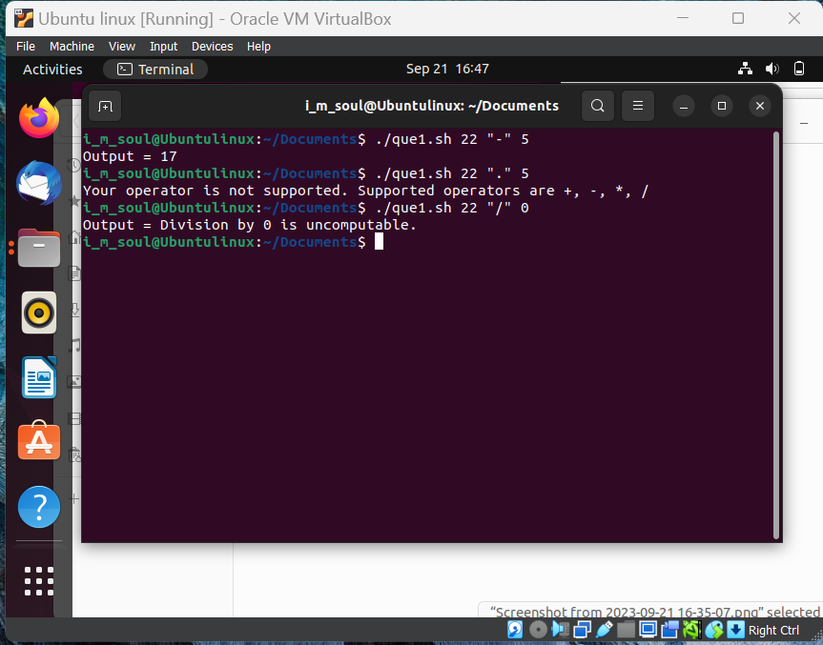

#!/bin/bash

sum=0

for num in "$@"; do

if [[ "$num" =~ ^[0-9]+$ ]]; then

sum=$((sum + num))

else

echo "'$num' is not a valid integer."

exit 1

fi

done

echo "Sum of thise number is $sum"

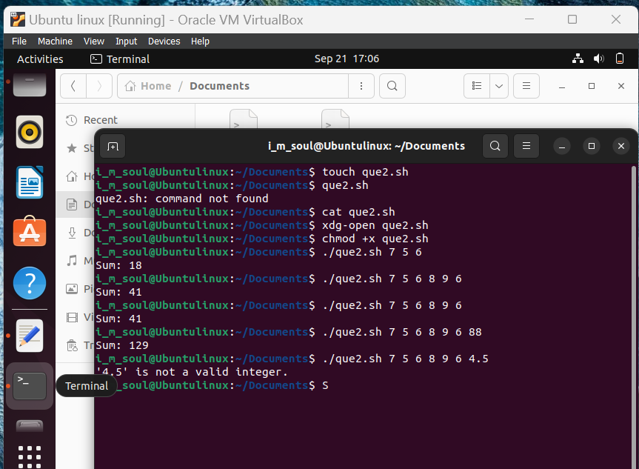

#!/bin/bash

string=""

for str in "$@"; do

string="${string}${str}"

done

echo "final string is $string"

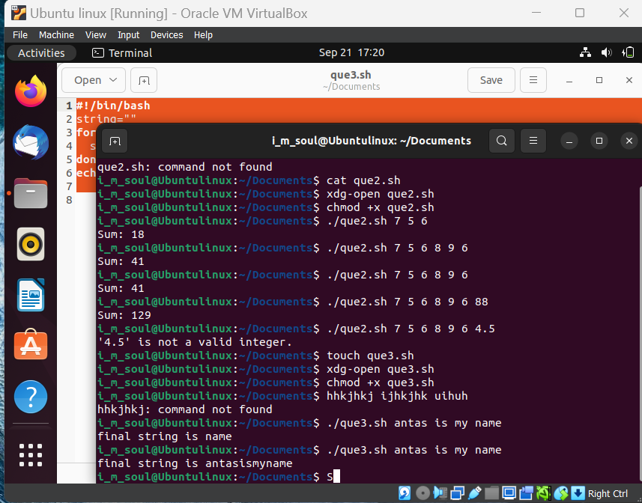

#!/bin/bash

countlines() {

if [ -f "$1" ]; then

lines=$(wc -l < "$1")

echo "Number of lines are $lines"

else

echo "File '$1' is not there."

fi

}

countlines "$1"

S

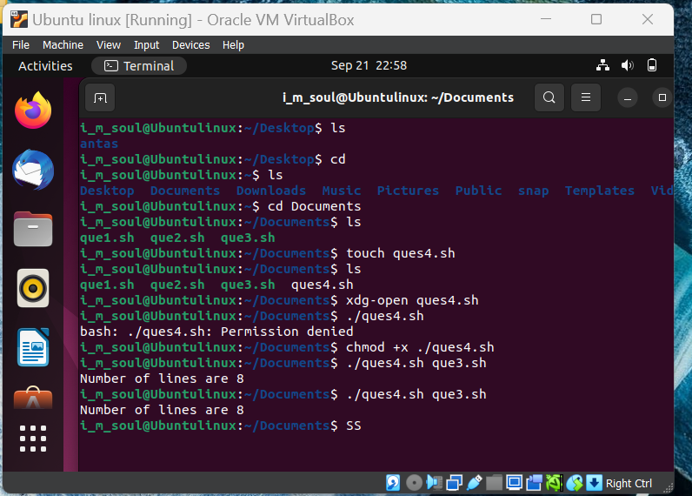

#!/bin/bash

lines() {

local totall=0

for file in "$@"; do

if [ -f "$file" ]; then

lines=$(wc -l < "$file")

totall=$((totall + lines))

else

echo "$file is not thier in the directory"

fi

done

return $totall

}

lines "$@"

totall=$?

echo "Total lines are $totall"

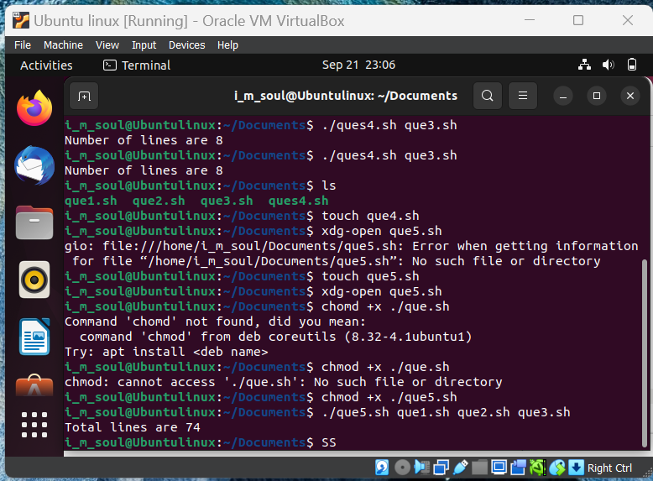

#!/bin/bash

for items in *; do

if [ -f "$items" ]; then

echo "File it is $items"

elif [ -d "$items" ]; then

echo "Directory it is $item"

else

echo "others $item"

fi

done

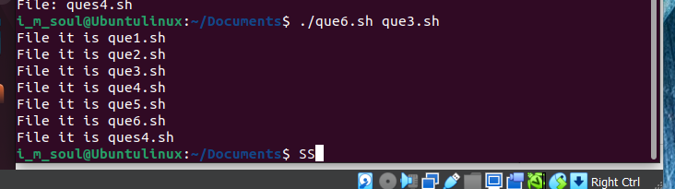

#! /bin/bash

echo "Hello world"

echo "i am learning shell script"

a="this is a string variable a"

echo $a

echo $BASH

echo $HOME

echo $PWD

name=Antas

echo the name is $name

# "variable" and "equal-sign" should be touching each other

# in this i didn't put "" in echo statement and just output the string

#! /bin/bash

echo enter your name

read name

echo you entered $name

echo enter 3 names

read name1 name2 name3

echo "$name1 is $name2 and $name3"

read -p 'enter on this smae line' line

echo $line

read -sp 'password' pass

echo $pass

echo "Enter names for array"

read -a names

echo "${names[0]}"

echo "${names[1]}"

echo "${names[2]}"

read # this is empty defaoult variable for reading

echo $REPLY

#! /bin/bash

echo $1 $2

argarr=("$@")

echo ${argarr[0]}

echo ${argarr[1]}

echo ${argarr[2]}

echo $@

echo this is the number of argument apassed $#

#! /bin/bash

count=10

if [ $count -eq 10 ]

then

echo "yes"

fi

if (( $count < 11 ))

then echo "yes"

fi

str="antas"

if [ $str == "antas" ]

then

echo "yes"

fi

if [[ $str < "zzzzz" ]]

then

echo "yes"

fi

#! /bin/bash

count=11

if [ $count -eq 10 ]

then

echo "yes"

else

echo "no"

fi

if [ $count -eq 10 ]

then

echo "yes"

elif (( $count>10))

then

echo "atleast it is greater"

else

echo "no"

fi

#! /bin/bash

sum=1

for num in "$@"; do

sum=$(echo "scale=5; $sum / $num" | bc)

done

echo $sum

#! /bin/bash

vehicle=$1

case $vehicle in

"car")

echo "rent is 33" ;;

"bus")

echo "rent is 11" ;;

[0-9] )

# ? for a character special

echo "34792479";;

* )

echo "invalid" ;;

esac

#! /bin/bash

os=('ubuntu' 'windows')

echo "${os[0]}"

echo "${os[@]}"

echo "${#os[@]}"

#how to read a file

#! /bin/bash

while read p

do

echo $p

done < hello.sh

#! /bin/bash

add()

{

echo $1+$2 |bc

}

res=$(add $1 $2)

echo $res

#!/bin/bash

str=('1' '2' '3' '4')

for i in "${str[@]}"; do

echo "$i"

done

#! /bin/bash

n=10

while (($n>1))

do

echo $n

n=$(($n-1))

done

#!/bin/bash

str=('1' '2' '3' '4')

for i in "${str[@]}"; do

echo "$i"

done